API Key Addition

1. Select the cog wheel on the left side for settings.

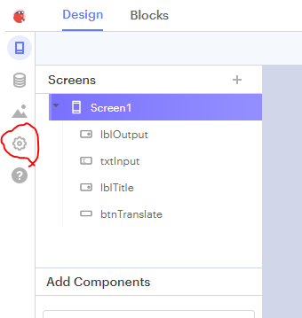

1. Then scroll down until you see the Yandex API Key input box.

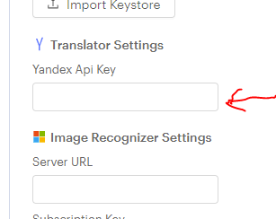

1. Either type or Copy/Paste the following key into that box

trnsl.1.1.20220615T022619Z.1d2b9b1f778800cc.df2b15b9432d2173b9dc1d6e26547e667379f760

Your app should now be using the GenCyber Key to access the App. Otherwise you would get a notice that the number of translations has been used up for the Free Key.